Testing Documentation – Assignment 2

|  |  |  |  |
| --- | --- | --- | --- |
| Testing ID | Description | Expected Outcome | Result |
| 1 | TCP Small Packet | Fast/No packet Loss | As Expected |
| 2 | UDP Small Packet | Fast/No packet Loss | As Expected |
| 3 | TCP Medium Packet | Fast to medium/ no packet loss | As Expected |
| 4 | UDP Medium Packet | Fast/none to little packet loss | As Expected |
| 5 | TCP Big Packet | Medium to Slow/no packet loss | As Expected |
| 6 | UDP Big Packet | Fast/lots of packet loss | As Expected |

Test 1: TCP Small Packet

Sender:

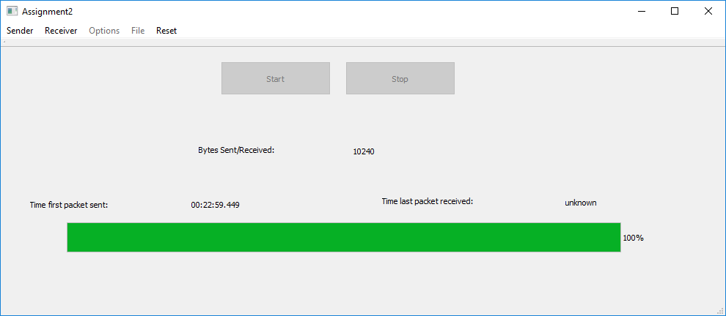

Receiver:

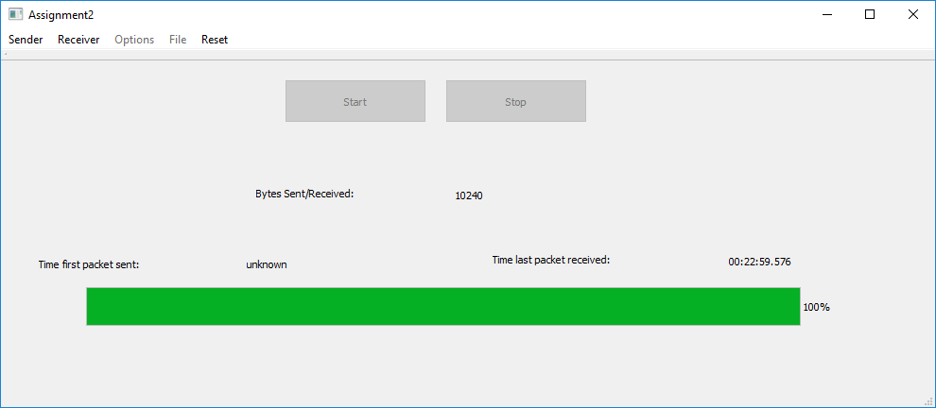

Result:

Time = 127ms

Packets lost = 0

Fast/No packet loss

Test 2: UDP Small Packet

Sender:

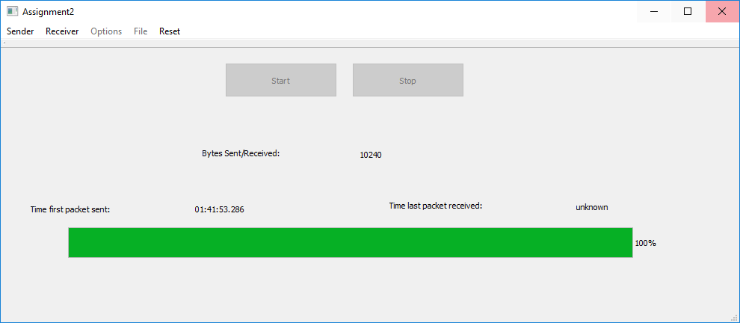

Receiver:

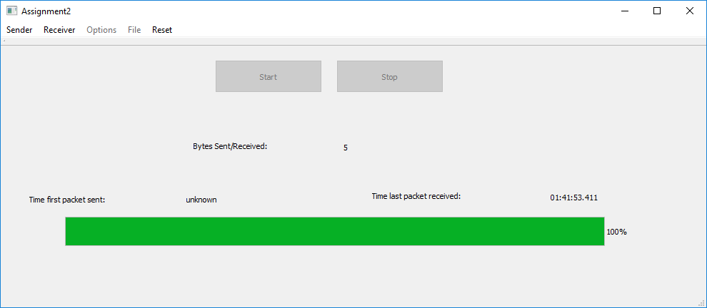

Result:

Time = 125ms

Packets lost = 0

Fast/No packet loss

Test 3: TCP Medium Packet

Sender:



Receiver:



Result:

Time = 127ms

Packets lost = 0

Fast/No packet loss

Test 4: UDP Medium Packet

Sender:

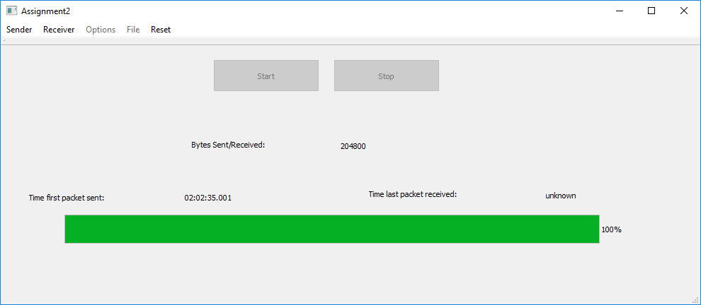

Receiver:

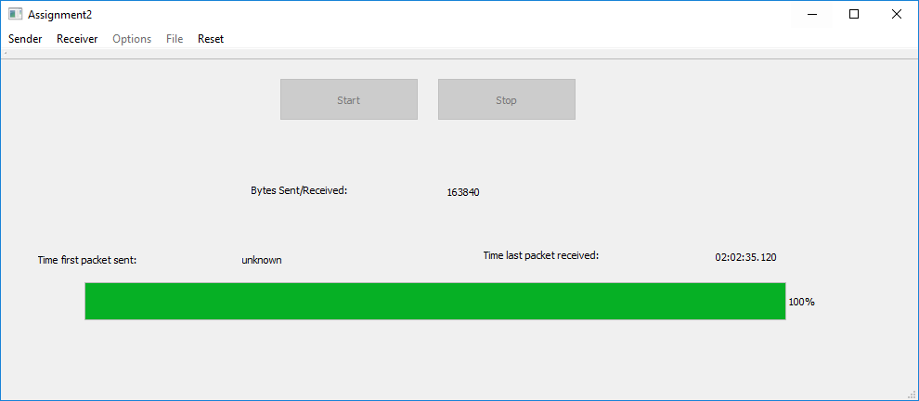

Result:

Time = 119

Packets lost = 20%

Fast/Some Packet Loss

Test 5: TCP Big Packet

Sender:

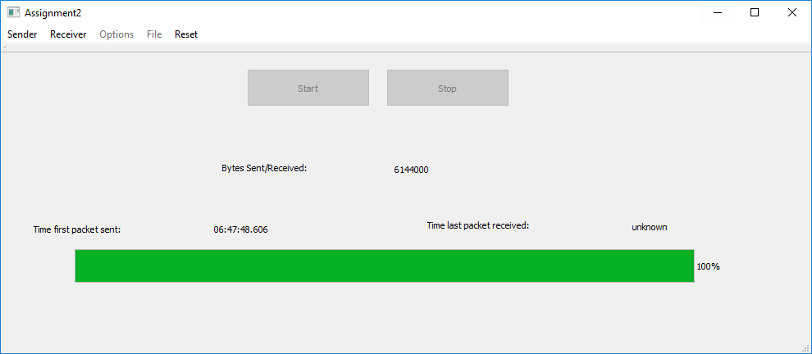

Receiver:

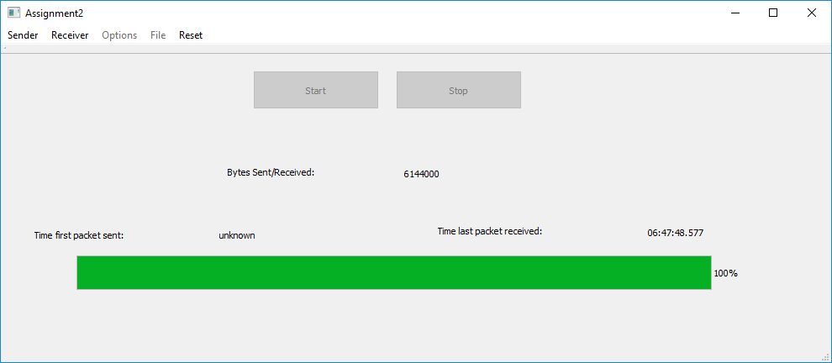

Result:

Time = 128

Packets lost = 0

Fast/No packet loss

Test 6: UDP Big Packet

Sender: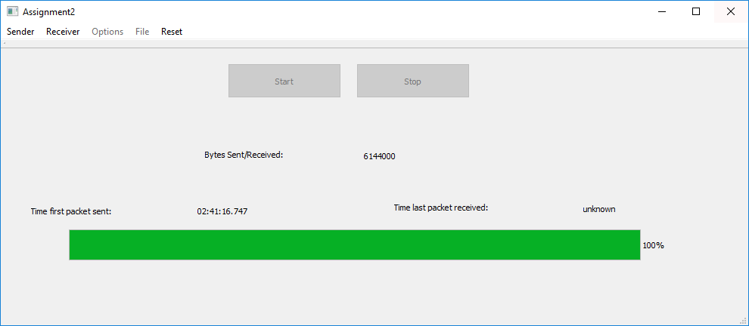

Receiver:

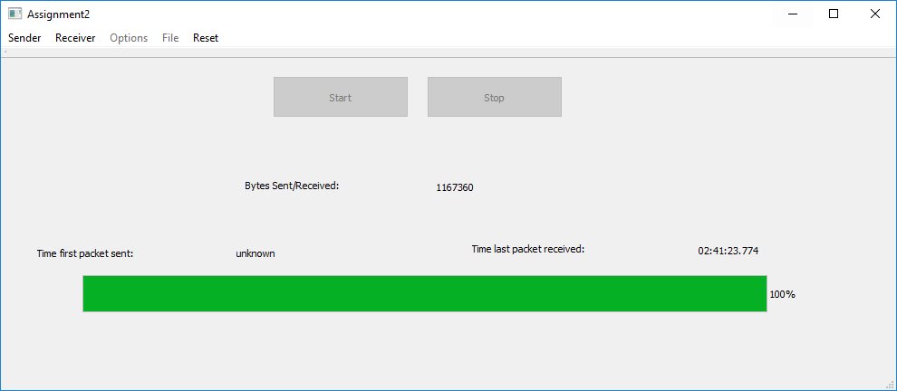

Result:

Time = 118

Packet Loss = 81%

Fast/No packet loss